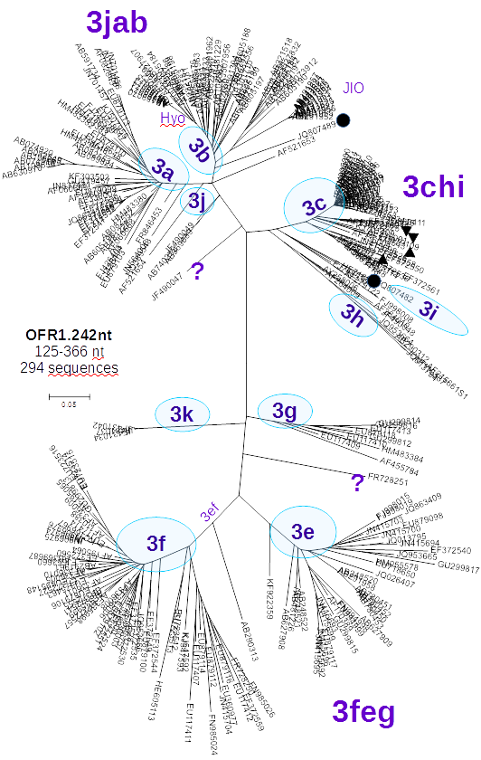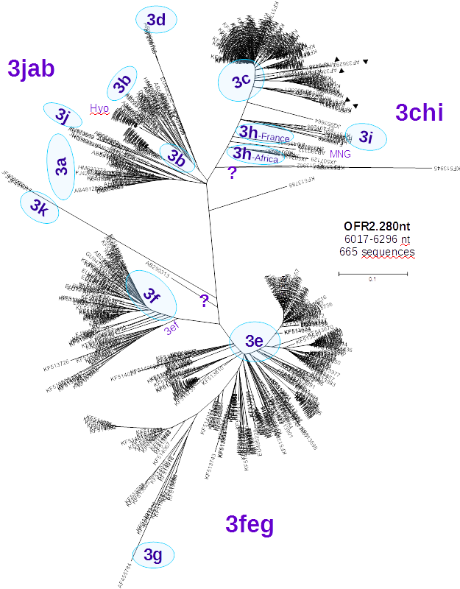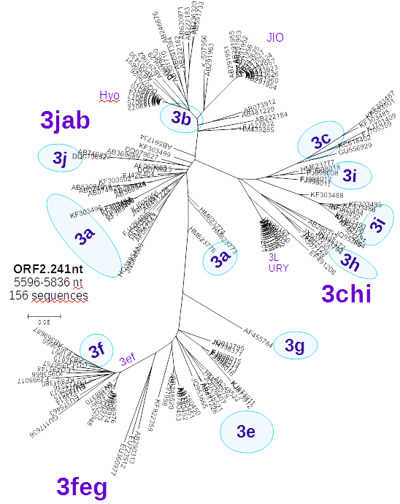

**(a)**

**(c)**

**(b)**

**Suplementary Figure S03.** Molecular phylogenetic analysis of: (a) **ORF1.242nt (left):** 294 partial HEV-3 genome sequences spanning the region 125-366 nt including all the sequences from figure 2 in [32], a large number of European sequences, partial sequences from animals WS34-10: (●) JQ807489, and (●) JQ807482, and stool pools from Netherlands: 3c (▲) NLSW36 and NLSW105 and 3c+3f: (▼)NLSW20 and NLSW99 [see discussion]; (b) **ORF2.280nt (center):** 665 partial HEV-3 genome sequences spanning the region 6017-6296 nt including near 500 sequences from England and Wales (Ijaz et. al 2014), and from the same stool pools from Netherlands: (▲) and (▼); (c) **ORF2.241nt (right):** 156 partial HEV-3 genome sequences spanning the region 5596-5836 nt. Detailed view of all the sequences used can be seen in Supplementary Figures S04, S05 and S06 respectively.